|  |  |  |
| --- | --- | --- |
| **Credit Hours System**  **CMPN111 – Logic Design 2** |  | **Cairo University**  **Faculty of Engineering** |

Assignment (2)

**Submitted to:** Eng. Abdelrahman Abotaleb

Eng. Yahia Zakria

**Members:** Mohab Hassan 1170281

Omar Essam 1161335

Alaa Medhat 1162336

Mohamed ELSayed 1170239

**Submission Date: 14.4.2020**

***Single Layer***

* ***Utilization Report:***

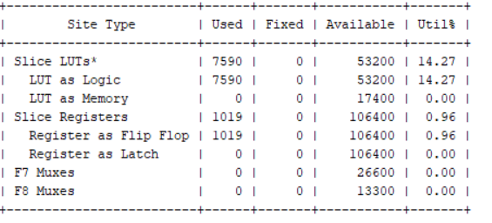

* ***Schematic Design:***

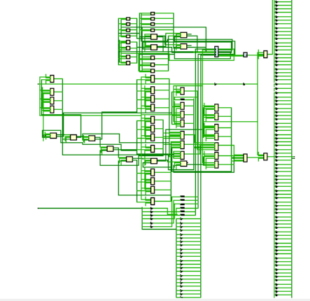

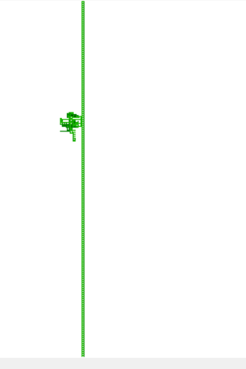

***Single Layer***

* ***Utilization Report:***

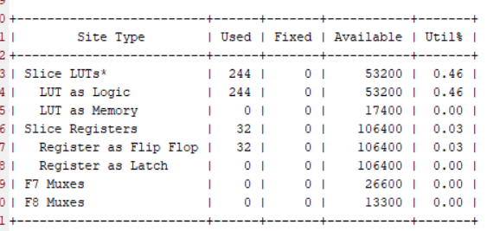

* ***Schematic Design:***

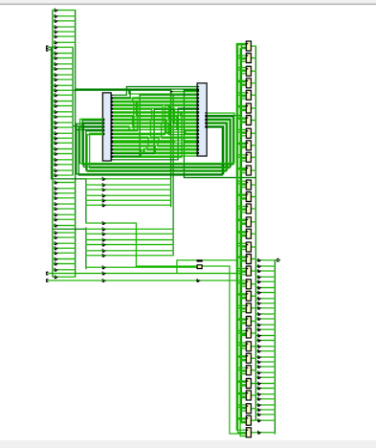

***Multiplier***

* ***Utilization report:***

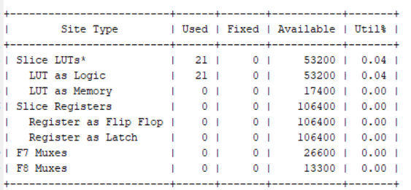

* ***Schematic Design:***

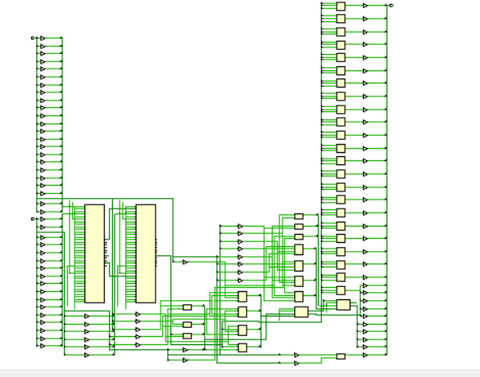

***Adder***

* ***Utilization Report:***

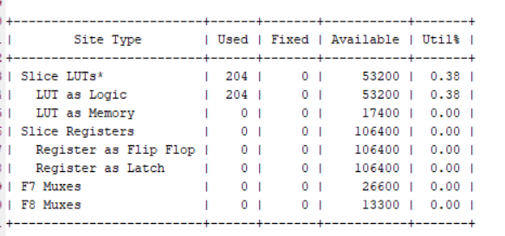

* ***Schematic Design:***

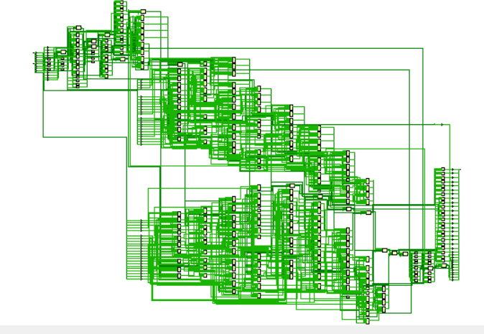

***Pipeline***

